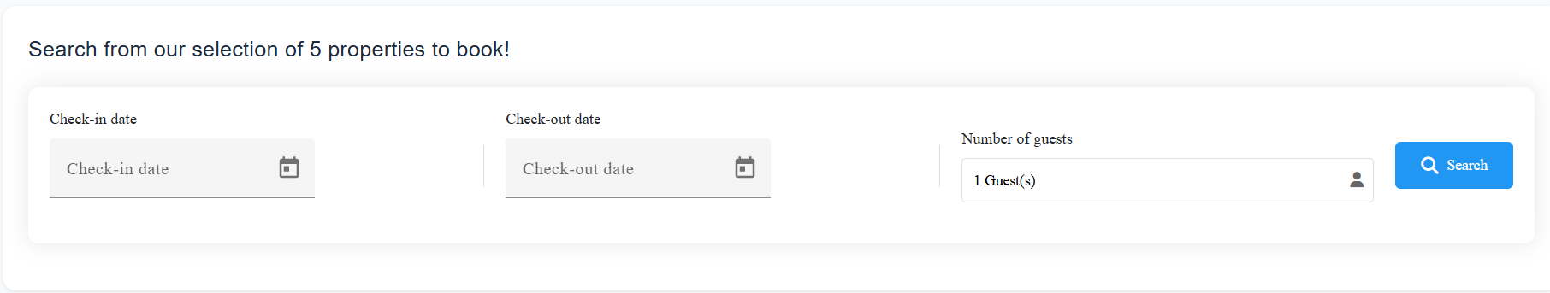

Its too white, not attractive, add a border blue maubook colour with it. And the search button , change the colour to maubook colour.



This should be bold and a little bigger



This also should be bold and a little bigger

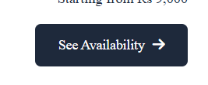

Instead of see availability, put it Book Now



When you click on book now. When it goes to the next page it goes to the footer of the page, it should not happen. see example

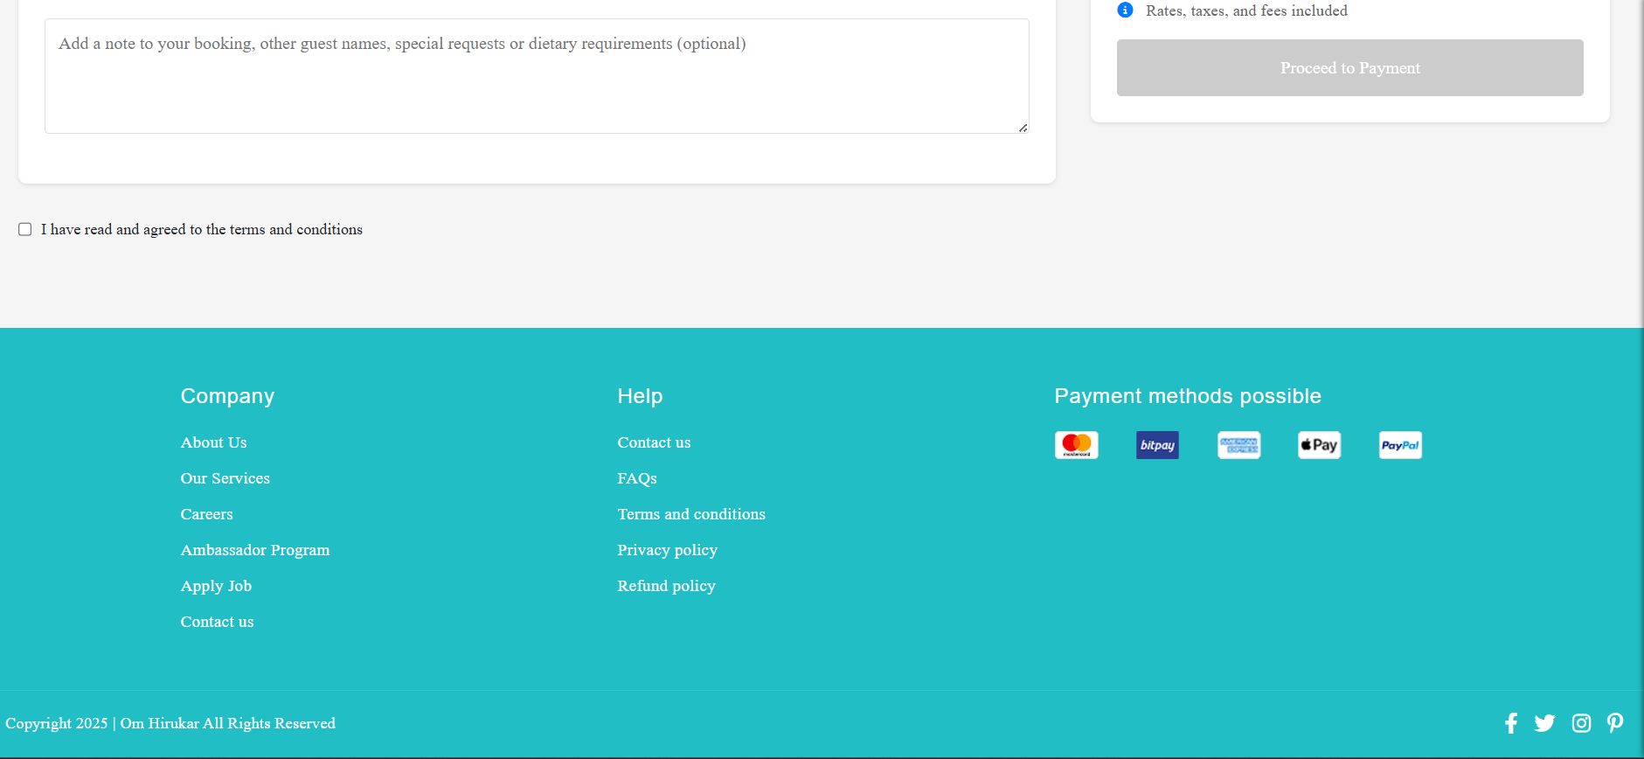



Change colour

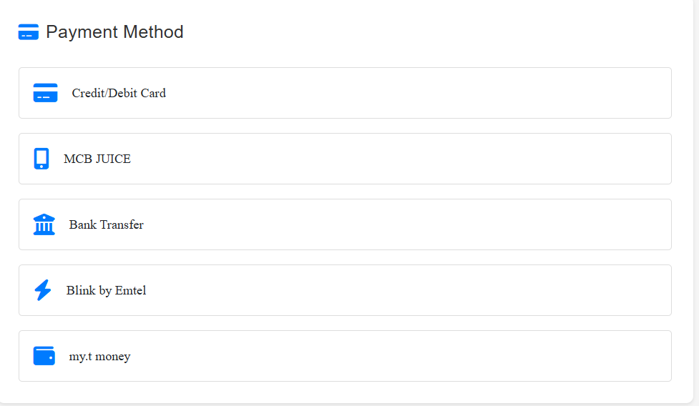

Should change icon colour, bold text , remove blink by emtel, remove my.t money

And scan to pay

\* add % commison

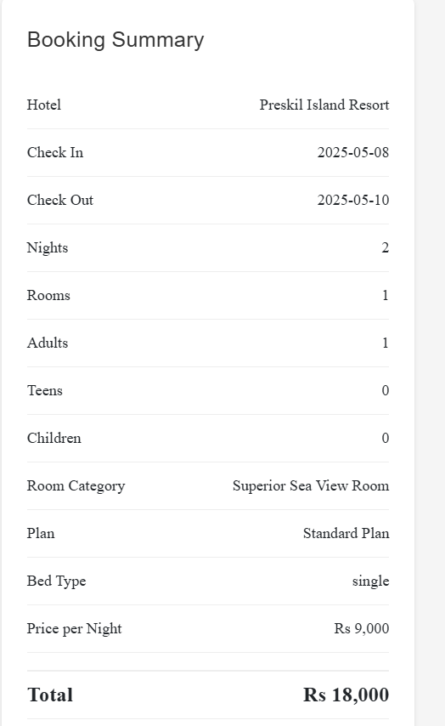

Can we put it in a blue border box



Change colour



Shorten the reference booking

Its not mobile friendly, check pictures below

